STARAGILE TERRAFORM ASSIGNMENT -2

**Steps to Deploy using Terraform**

1. **Install Terraform**:

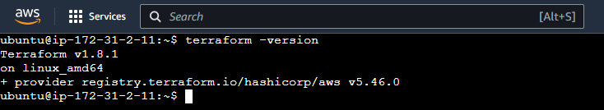

1. **Create Terraform Files**: main.tf

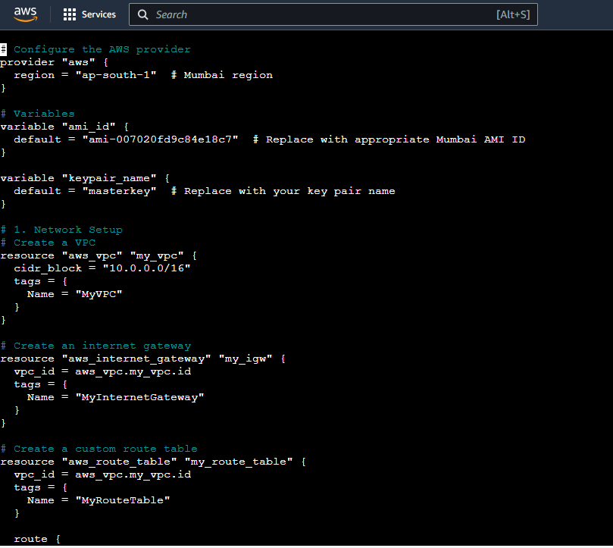

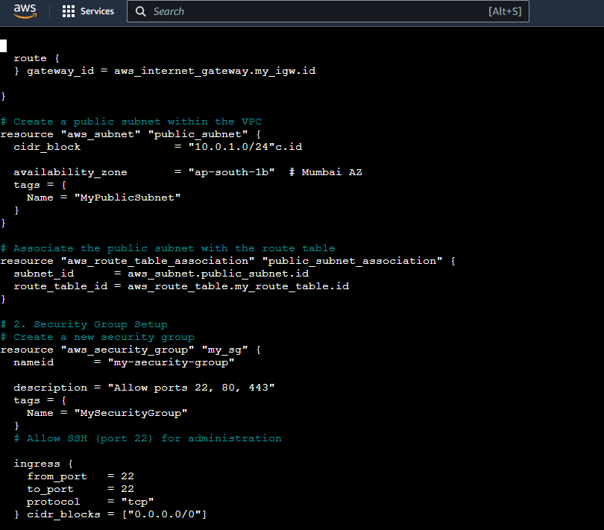

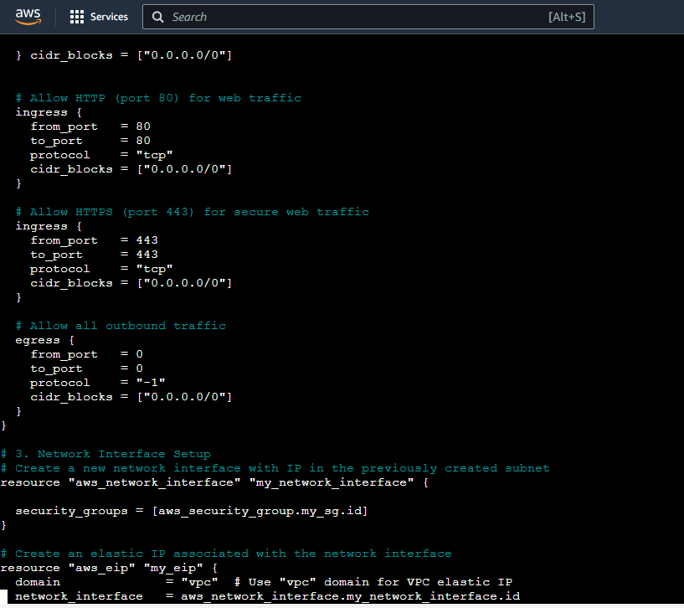

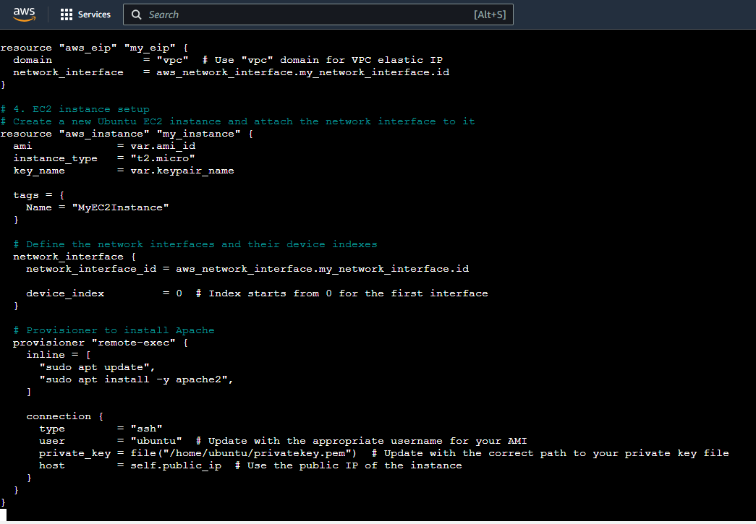

1. **Initialize Terraform**: terraform init

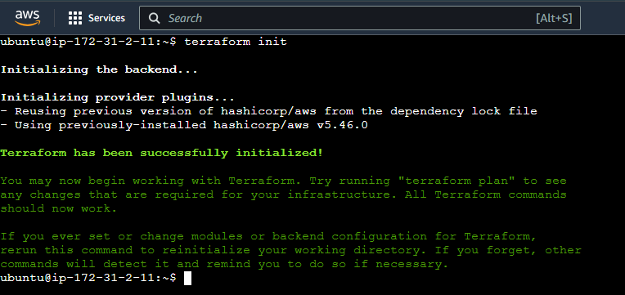

1. **Review Plan**: **terraform plan** 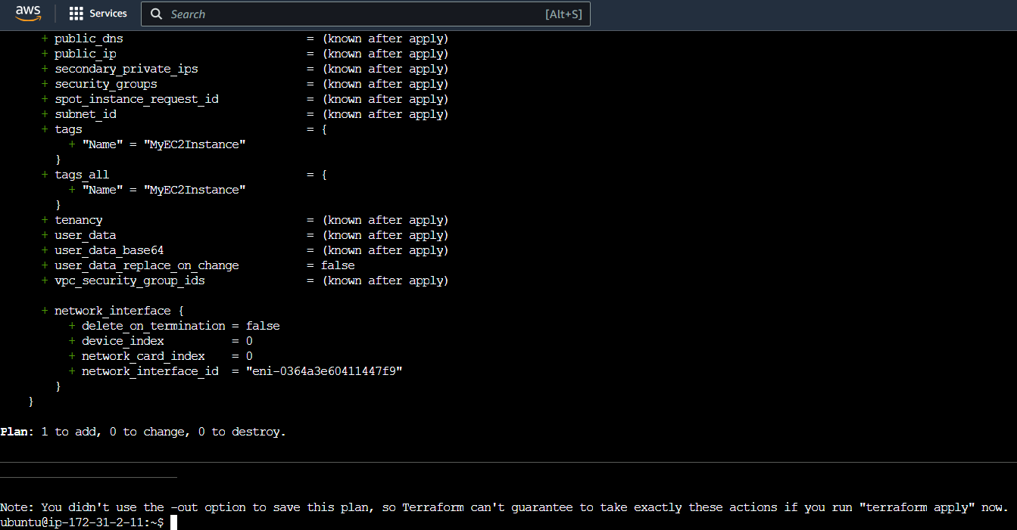
2. **Apply Changes**: **terraform apply**

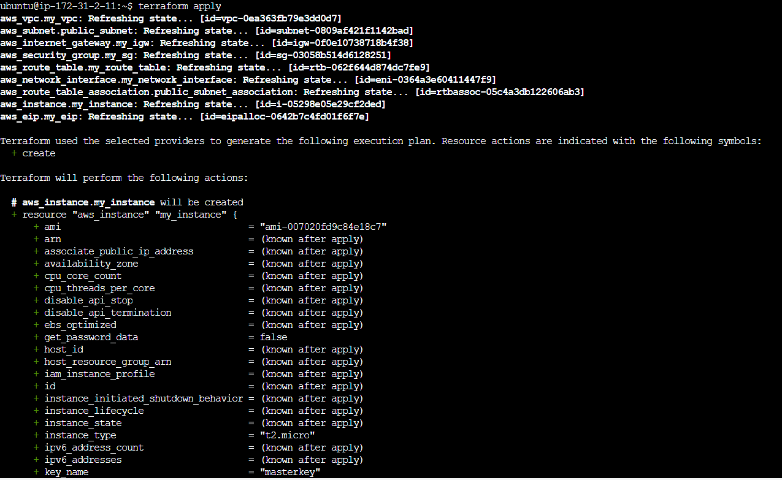

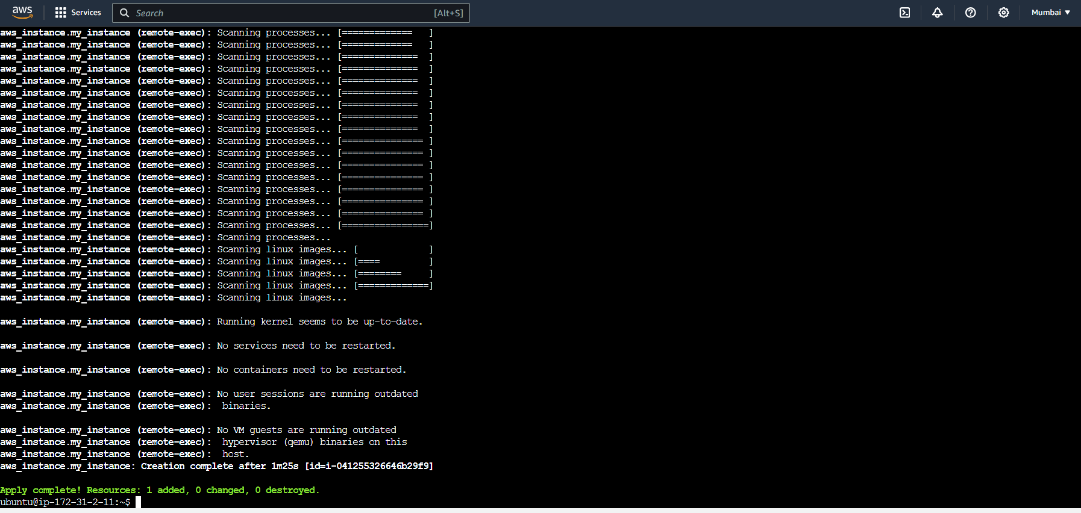

1. **Verify Resources**: verify in the AWS Management Console that the resources have been created as expected

Verification   
**Network Setup**:

* + **VPC Creation**:.
    - Check for the VPC named "MyVPC" with CIDR block "10.0.0.0/16".
    - Ensure that there are no errors reported for the VPC.

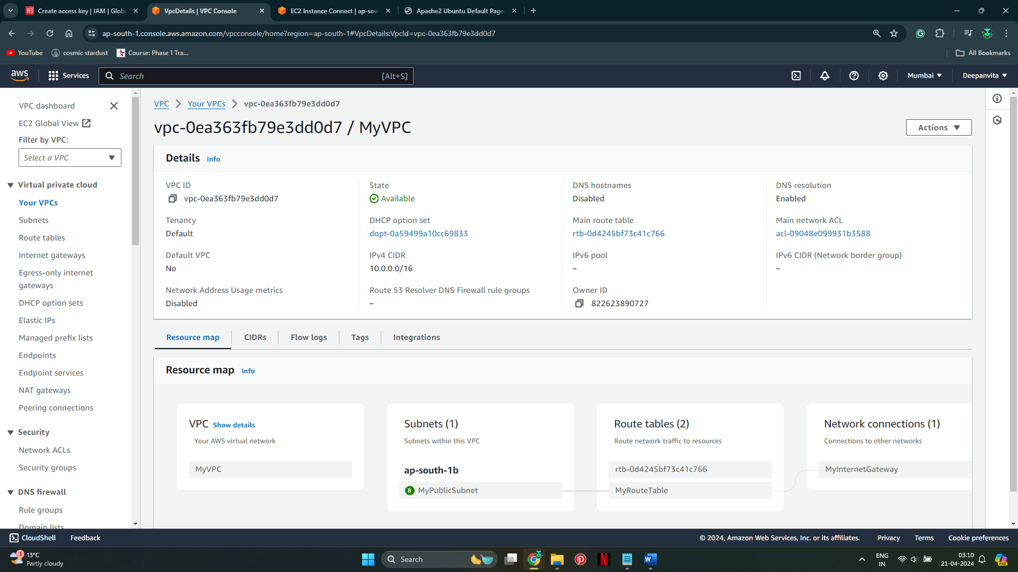

* + **Internet Gateway Creation**:
    - Verify that an internet gateway named "MyInternetGateway" is attached to the VPC "MyVPC".

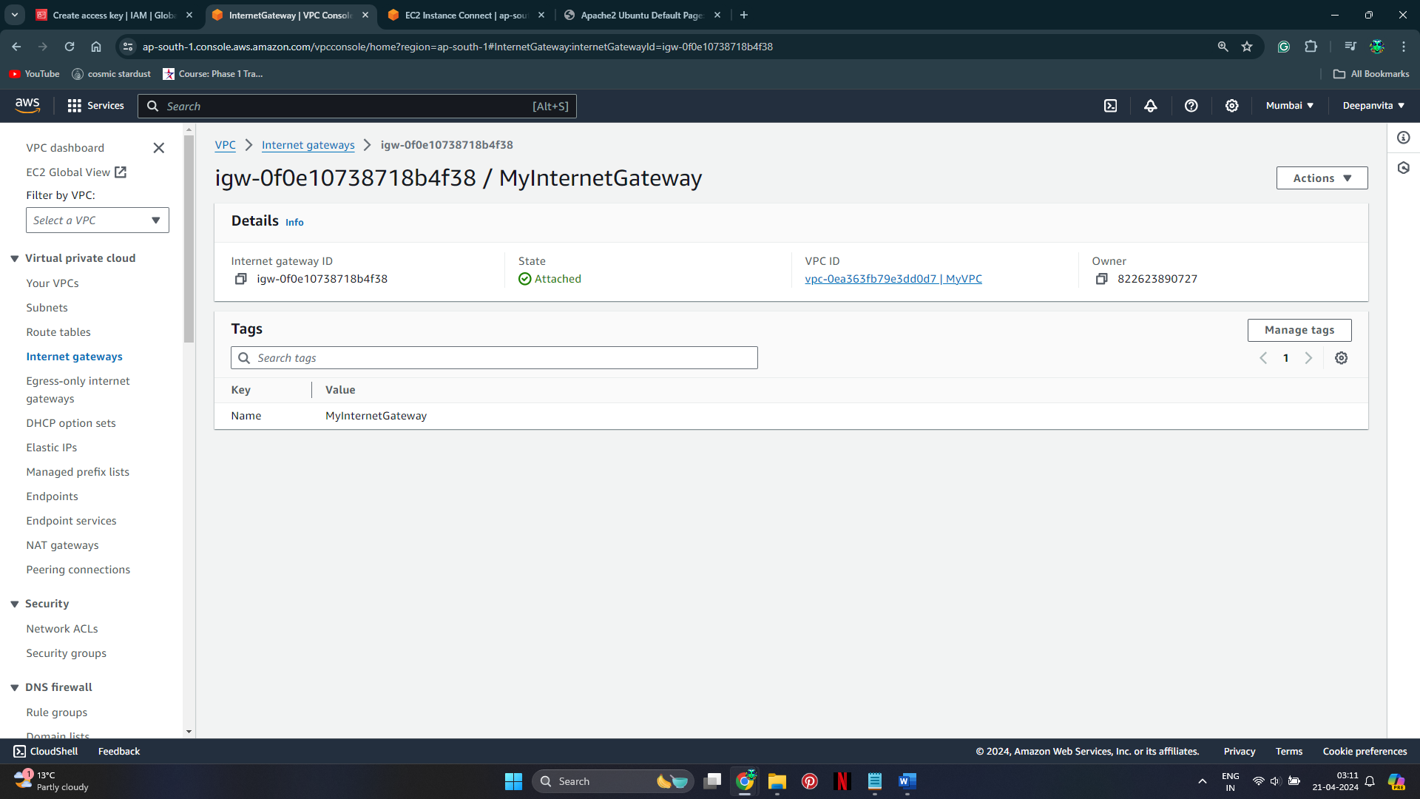

* + **Custom Route Table Creation**:
    - Find the route table named "MyRouteTable".
    - Check that it is associated with the VPC "MyVPC" and has a route to the internet gateway.

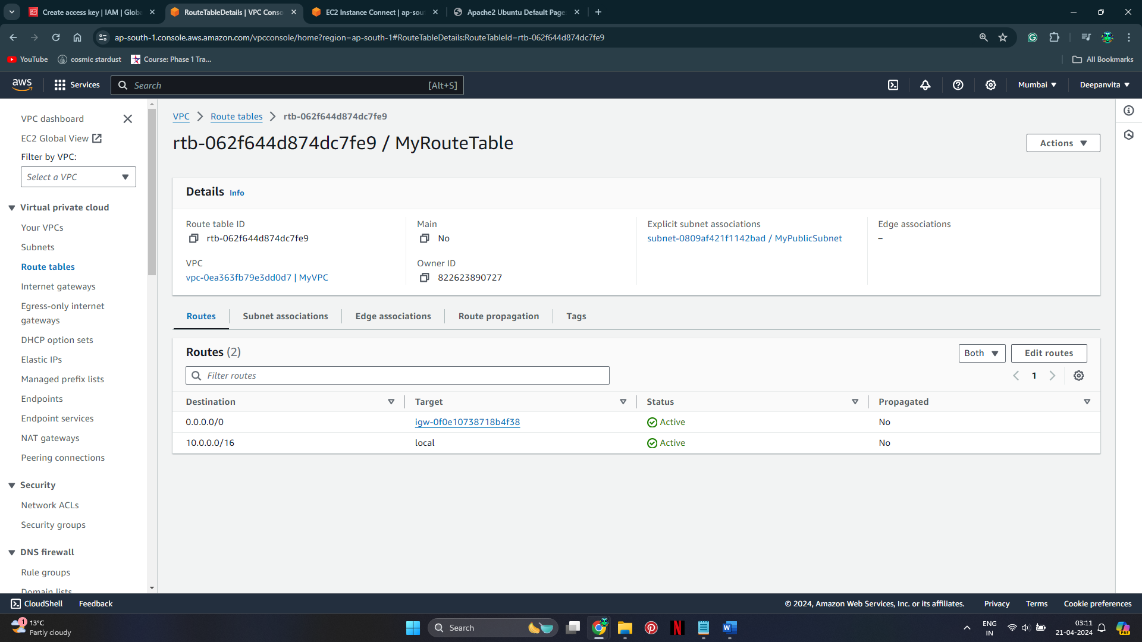

* + **Subnet Creation and Association**:
    - Look for a subnet named "MyPublicSubnet" with CIDR block "10.0.1.0/24".
    - In the VPC service, check the subnet associations of "MyPublicSubnet".
    - Ensure that it is associated with the route table "MyRouteTable".

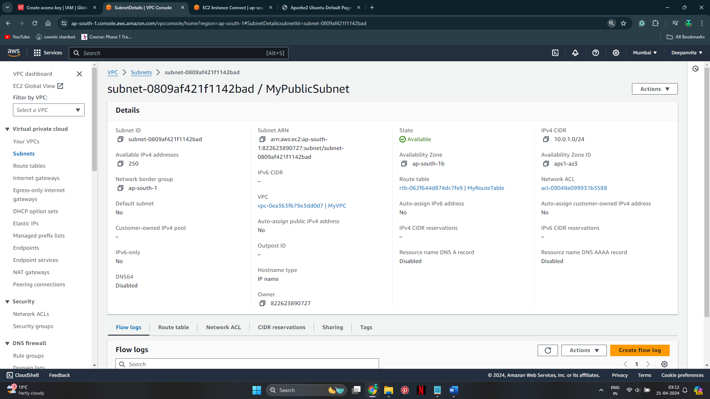

1. **Security Group Setup**:

Verify that a security group named "MySecurityGroup" exists and is associated with the VPC "MyVPC".

* + Check the inbound rules to confirm that ports 22, 80, and 443 are open.

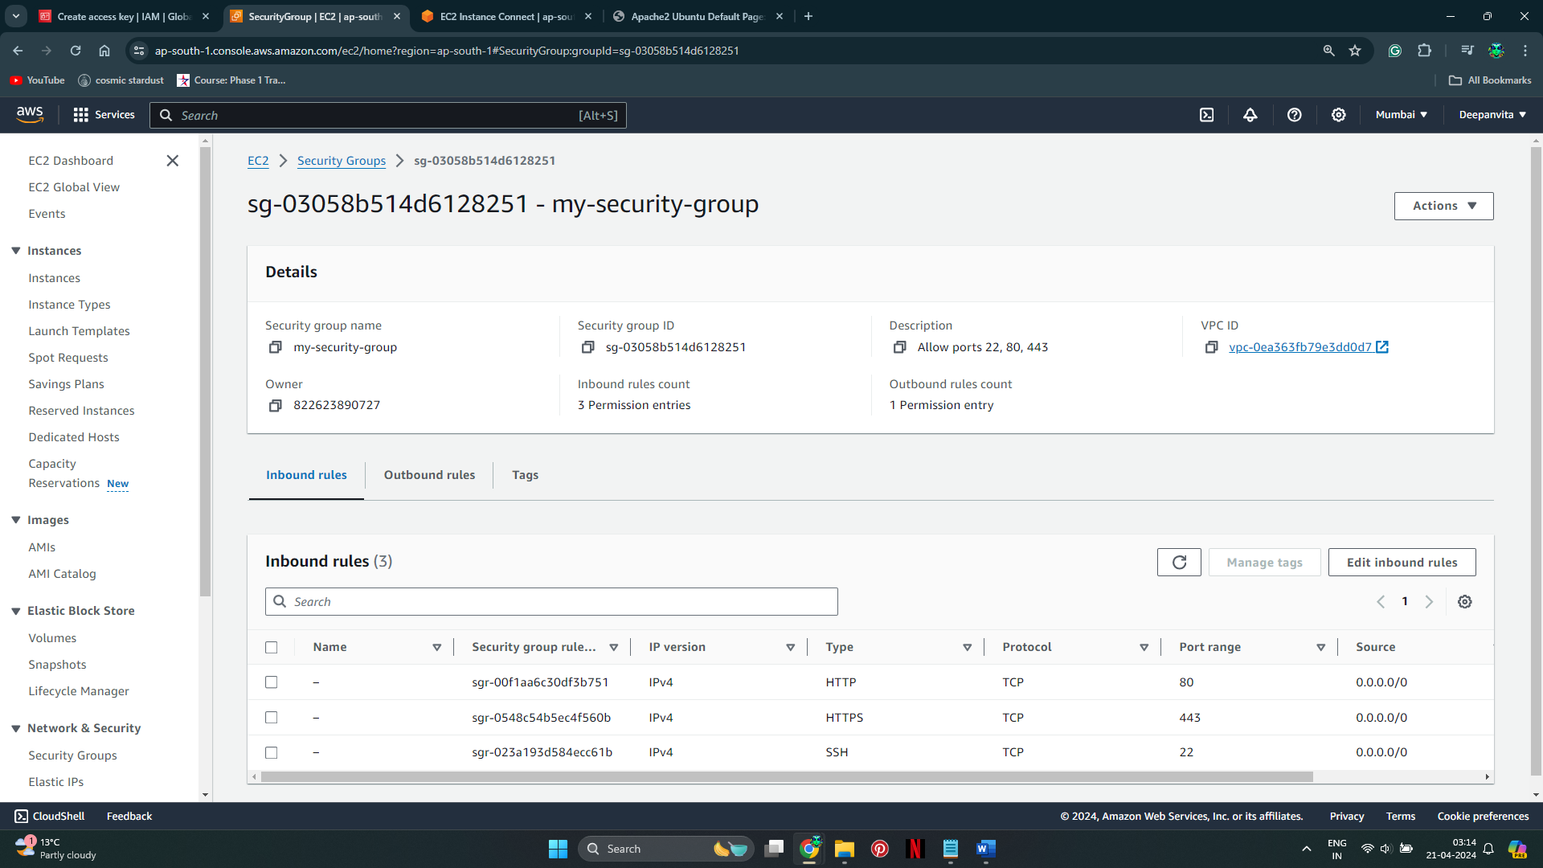

1. **Network Interface Setup**:
   * Look for a network interface associated with the subnet "MyPublicSubnet" and security group "MySecurityGroup".
   * Confirm that an Elastic IP is associated with this network interface.

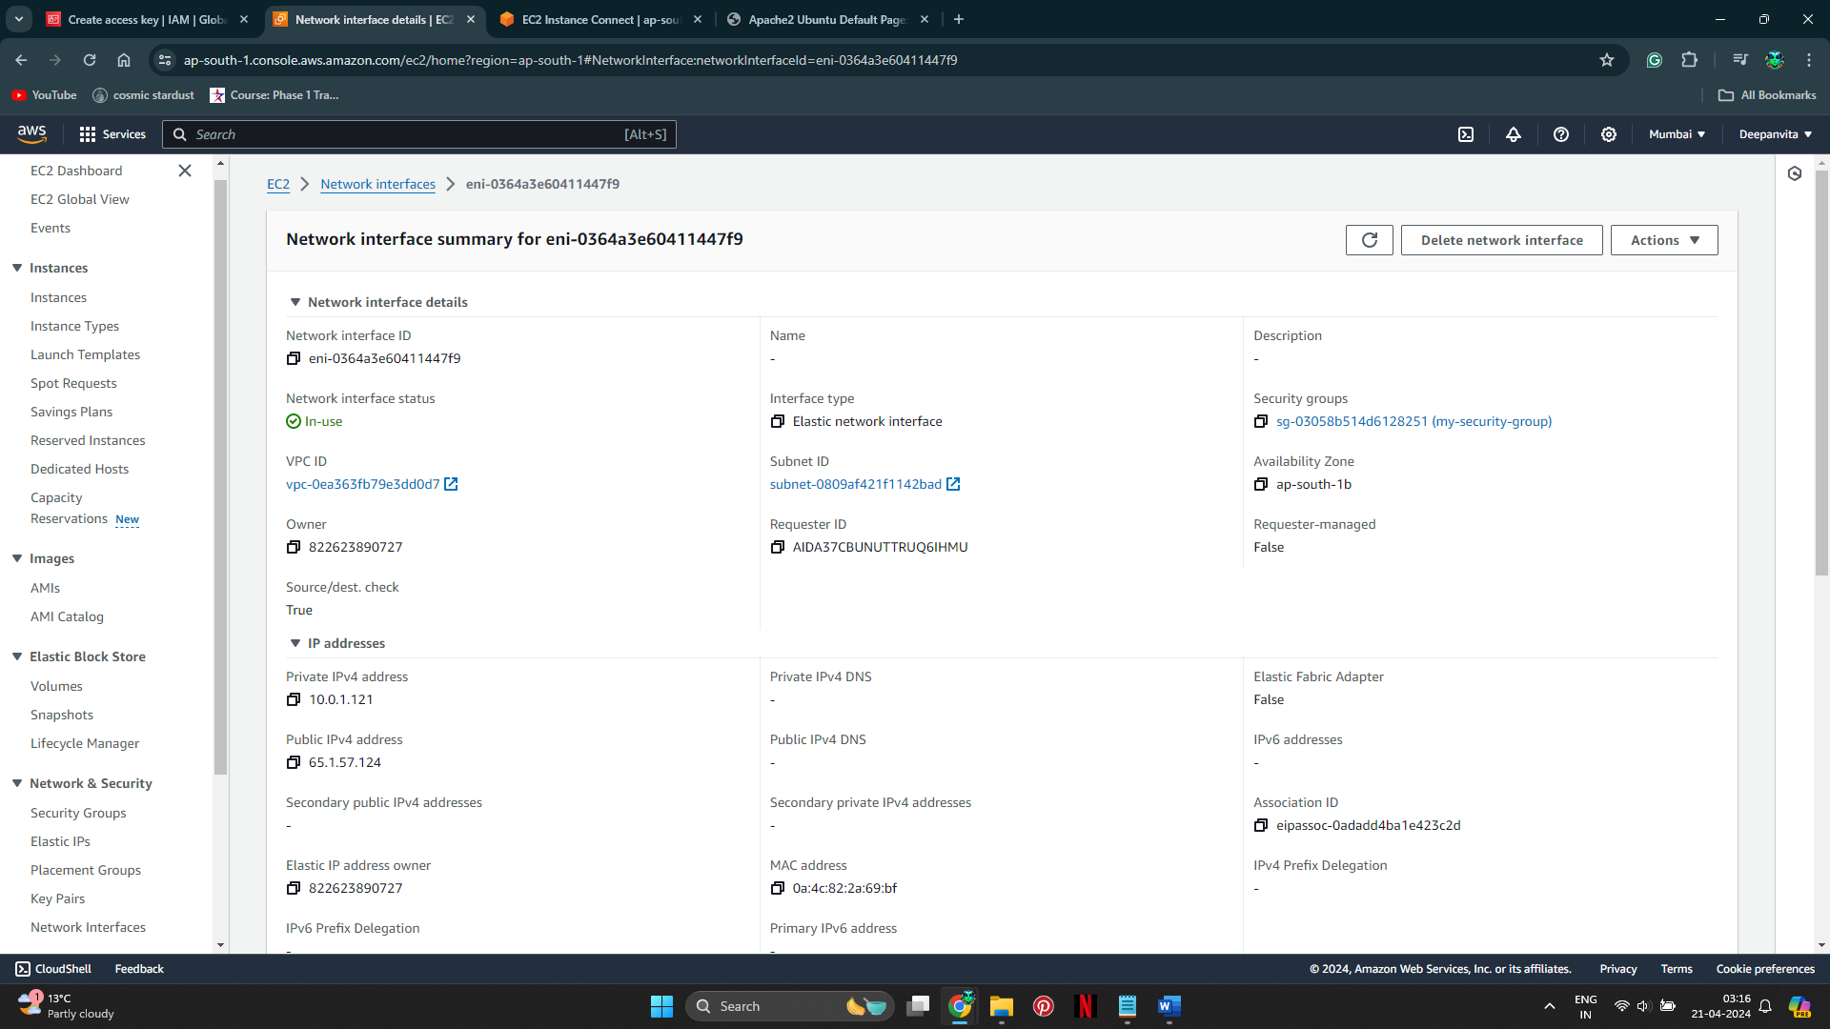

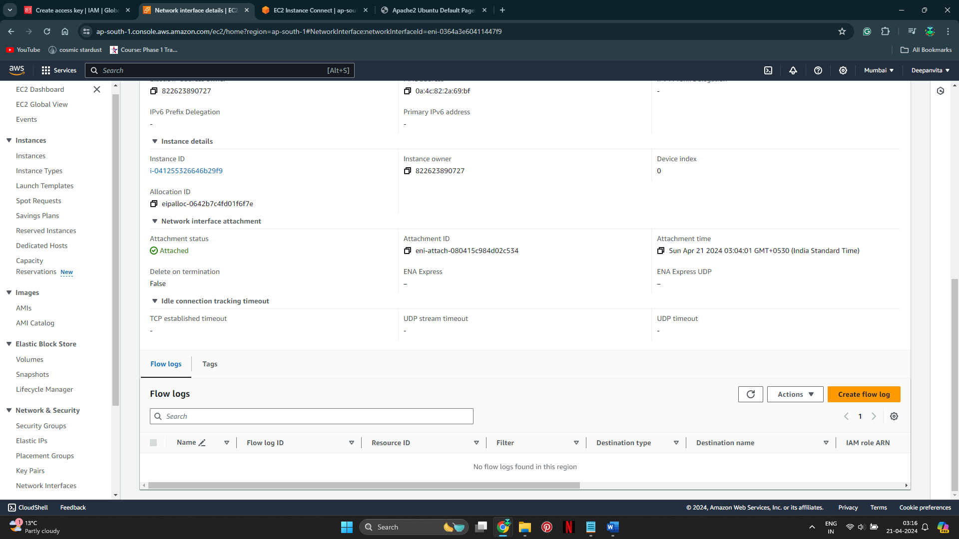

1. **EC2 Instance Setup**:
   * Find the EC2 instance named "MyEC2Instance".

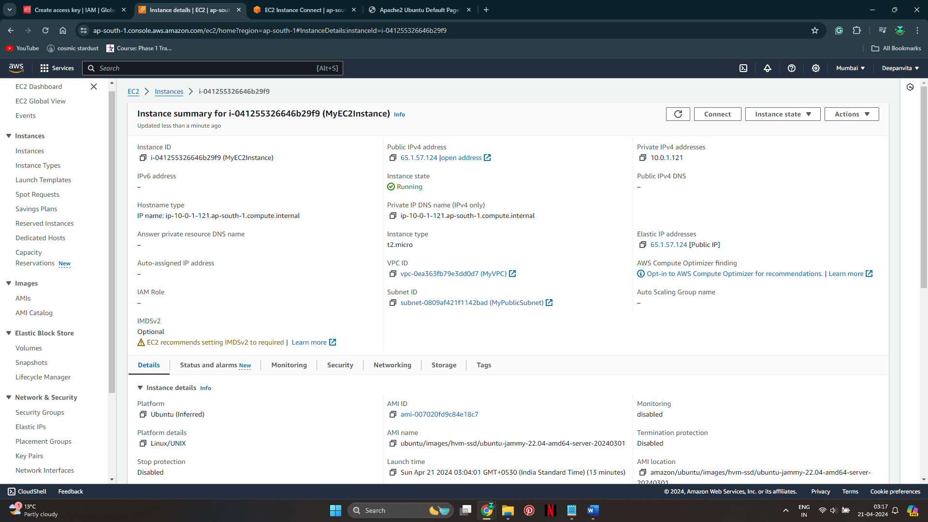

* + Check that it is running and has the correct configuration, including the associated network interface.

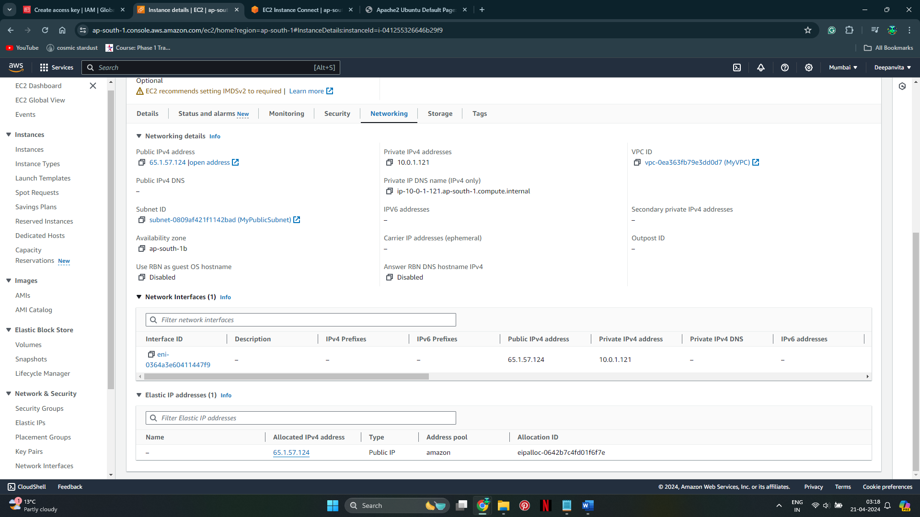

* + SSH into the instance and verify that Apache is installed by running **sudo systemctl status apache2**.

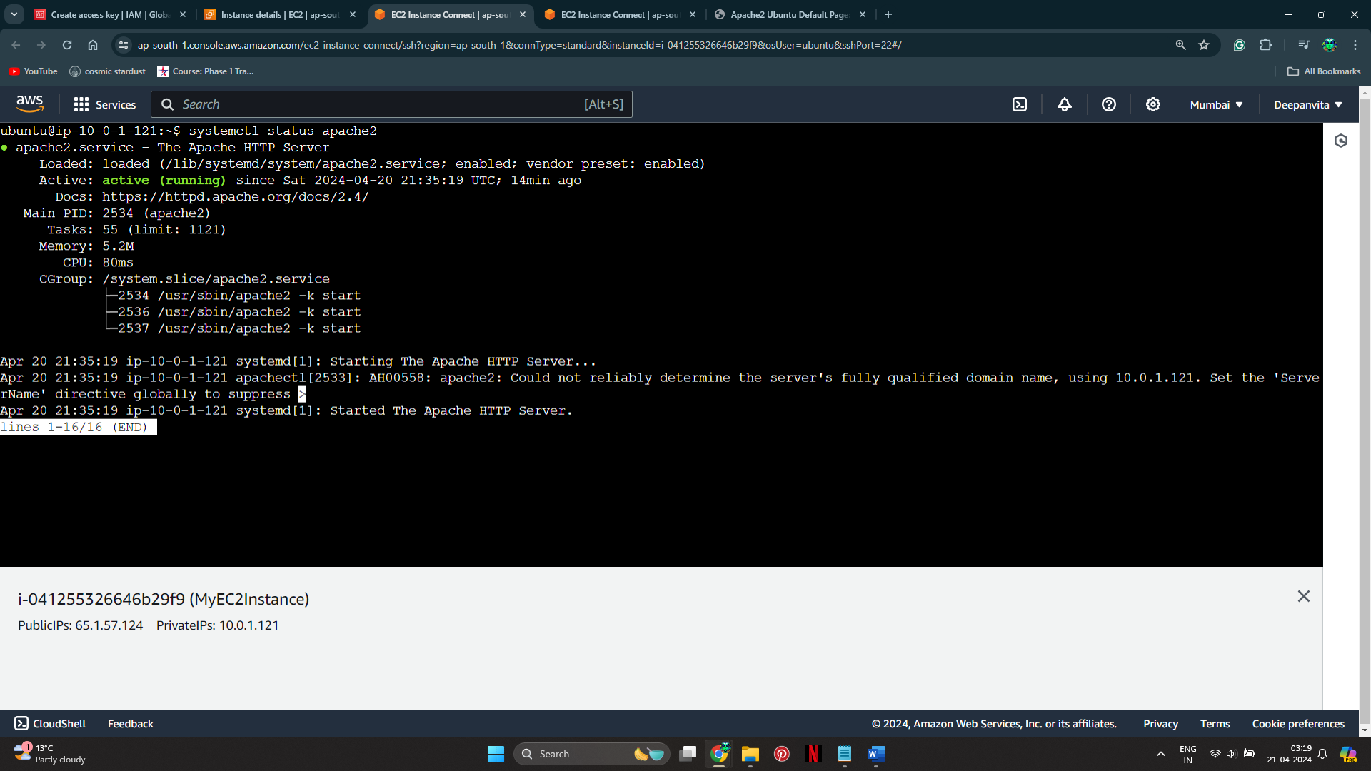

* + Access the public IP of the instance in a web browser to confirm that Apache is serving a default webpage.

